Computing – Year 5/6 (Cycle A) – Images: Photoshopping
Lesson Objectives | Prior Knowledge |  | Lesson Objectives
 | Year 3:  - Use leading lines and the rule of thirds to draw attention towards a focal point.  - Apply filters to establish mood.  - Take horizontal and vertical panoramic photos.  Year 4:  - Take and select photos using burst mode.  - Apply the long exposure effect.  - Animate your photos. |  | Images:  - Use the clone stamp to remove items from picture.  - Change backgrounds, using layers to support composition.  - To combine multiple images  Presenting:  Evaluating:
 |   Saving and retrieving |   Typing and mouse skills |  |   Research |   Computer Systems
 |  |  |  | - Children to search the internet for a relevant and suitable picture. | - Recognise that data is transferred using agreed methods (airdrop).  - Children to be able to open website.

NC Links | Computing also ensures that pupils become digitally literate – able to use, and express themselves and develop their ideas through, information and communication technology – at a level suitable for the future workplace and as active participants in a digital world.
Vocabulary | Photoshop, layers, cutout, retouch, clone stamp.
Resources | Ipad  Pixlr website

Lesson 1 – E-Safety | Privacy and Security | Discuss: Why can we not trust everything we see on-line?  Responses: People pretending to be others, phishing, identity theft, on-line fraud, scamming, manipulated/fake pictures, cyber-bullying, viruses  Discuss: How can we ensure we maintain our e-safety on-line?  Responses: Be suspicious of unknown links - think before downloading, don’t share personal info, have strong passwords (including fingerprint/Face ID), think before clicking, think before posting (responding), set up privacy settings/age-related access, quality antivirus, check website reliability, data confidentiality,  Independent work: create a poster of set of rules based on the discussion on how to stay safe on-line…
Lesson 2 | WALT | Use the clone stamp to remove items from picture
 | Activate  5 mins | Talk children through the idea of photo shopping images – show examples from the internet . How do we know? What are the dangers? (fake news/ inaccurate information about people)
 | Teach  10 mins | Discuss how we will be looking at tools to manipulate images.  Discuss key vocabulary/tools:  Children to open website:  https://pixlr.com/x/#home  - Children to click ‘Open image’ and select an image.  - Down the side bar, select retouch .  - Select clone stamp .  - Click source and click on background to select what you would like to cover the area with.  - Select paint and paint over object/person in picture.  - Show how to pinch to zoom on and change brush/size hardness to make it accurate.  Use other source to tidy up image.
 | Practice | Core group: to remove an aspect of an image using the edit tools as accurately as possible.  Children to use pictures from Robin Hood Bay or from the internet and relating from a topic.  Children to use the tools to resize the pictures, then remove key aspects of the photo. Can the children make it as accurate as possible?  Supported group: as above but focus on the removal of a single item that is larger in size – Adult support  Extension/challenge: Can you remove smaller items and use the blurring tool to blend the editing as accurately as possible.
 | Evaluate  5 mins | Share photos from the class using screen mirror- discuss which look more effective.  What skills have the children learnt? Any problems?  What was most difficult?
Lesson 3 | WALT | Use layers to support composition
 | Activate  5 mins | Remind children of the skills taught last week. This week, we will be using layers.
 | Teach  10 mins | 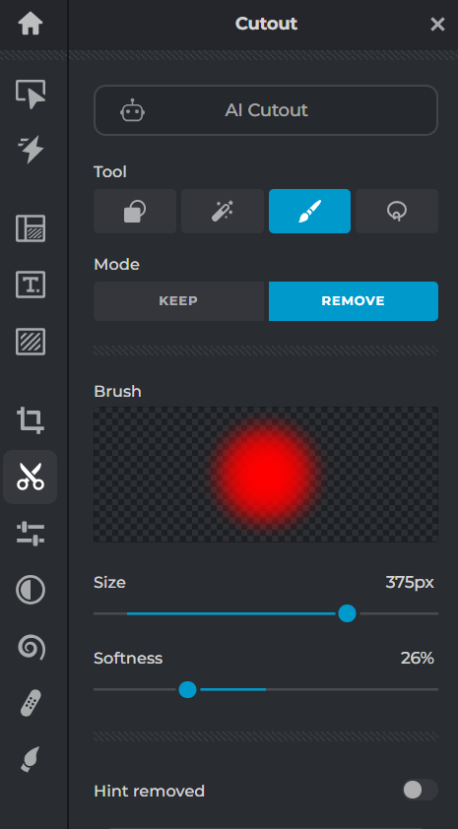  Layers are like transparent paper over each other. It allows you to change one picture without affecting the other one.  1. Add background picture of screen.  2. Click layer- add image as layer (person). Children may need five minutes to take a picture of each other. They need a clear full body picture of a person.  3. Click on the layer on the right of the screen and use the handles to resize the image of the person so they are an appropriate size.  4. Once it’s the right size, click away and confirm changes.  5. On the left of the screen click ‘cutout’.  6.Using the remove setting children to remove the background of the new layer.  7. Recommend to the children to use the ‘draw cutout’ tool.  8. Children to explore the different effect that changing the size and softness has.
 | Practice and  Apply | Core group: to edit and add aspects of a photo as accurately as possible.  To use layers and selection to combine images.  Children to create a fun photo that places themselves or someone famous into a different background.  Supported group: Provide simple backgrounds for children.  Extension/challenge: Can you merge 2 photographs together and import your own backgrounds. Careful selection of images to get similar perspectives. Use blur tools to make more realistic.
 | Evaluate  5 mins | Children to evaluate whether the images are cleaned up.  Do they look appropriate?  Did they face any challenges with their new skills?
Lesson 4 + 5 | WALT | To combine multiple images
 | Activate  5 mins | Remind children of all the skills we have learnt – adding / removing images , changing backgrounds and adding text.  Recap learning in previous years about taking good photos using an ipad and how to adjust brightness and colours.
 | Teach  15 mins | Explain that children will be making a postcard from a winter wonderland.  Pupils will choose their location and then take a photo of the pose they will be in (waving, climbing, smiling…)  Teach children how to adjust the image of themselves to match the colour and brightness on the background image.  Adjust light and colour (this can either be done in the photo app or using pixlr)  - Tap a photo thumbnail to view it in full screen.  - If you’re editing a video or a photo shot in Portrait mode, tap  on the left side of the screen.  - Tap Edit, then swipe up on the right side of the screen to view the effects you can edit such as Exposure, Brilliance, Highlights, and Shadows.  - Tap the effect you want to edit, then drag the slider to make precise adjustments.  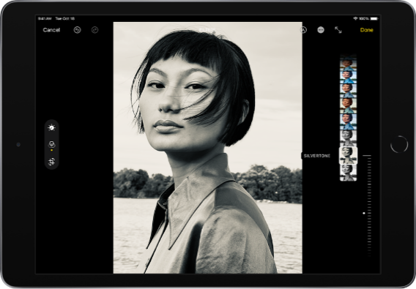  - The level of adjustment you make for each effect is indicated by the outline around the button, so you can see at a glance which effects have been increased or decreased. Tap the effect button to toggle between the edited effect and the original.  - Tap Done to save your edits, or if you don’t like your changes, tap Cancel, then tap Discard Changes.  Tip: Tap  to automatically edit your photos and videos with effects.  Apply filter effects  - Tap Edit, then tap  on the left side of the screen.  - Tap a filter on the right side of the screen, then drag the slider to adjust the effect.  To compare the edited photo to the original, tap the photo.  - Tap Done to save your edits, or if you don’t like your changes, tap Cancel, then tap Discard Changes.  Crop a photo  - Tap Edit, tap  on the left side of the screen, then do any of the following:  - Crop manually: Drag the rectangle corners to enclose the area you want to keep in the photo, or you can pinch the photo open or closed.  Straighten and adjust perspective  - Tap Edit, tap on the left side of the screen, then tap the effect button that you want to edit on the right side of the screen: Straighten, Vertical, or Horizontal.  - Drag the slider to adjust the effect.  The level of adjustment you make for each effect is displayed by the outline around the button, so you can see at a glance which effects have been increased or decreased. Tap the button to toggle between the edited effect and the original.  Tap Done to save your edits, or if you don’t like your changes, tap Cancel, then tap Discard Changes.
 | Apply | pupils will use the background image and the image of themselves to create a photoshopped image of themselves in the scene, using the layers, clone tool as well as adjusting the photo for brightness and colours to make it more realistic.
 | Evaluate  5 mins | Share phots and celebrate achievements.  Reflect on what went well and what thy might change next time.

